## 



Pinterest

18-2-2020

**─**

Habiba Khaled Mohamed Mahmoud sec(6)

Dina Abdallah said Ahmed sec(7)

Alaa Mohamed Mostafa Kamel sec(4)

Alaa Mahmoud Mohamed Abdulaziz sec(4)

Youssef Tarek Abd El-Aziz Ali sec(20)

# Preface

The purpose of Pinterest is to make it easier to share your best collection of images or introduce art through images and make people interact with those images. And they can prefer the collection as suitable images together or not . Here some similar apps to our app and our app and some features to express the program:-

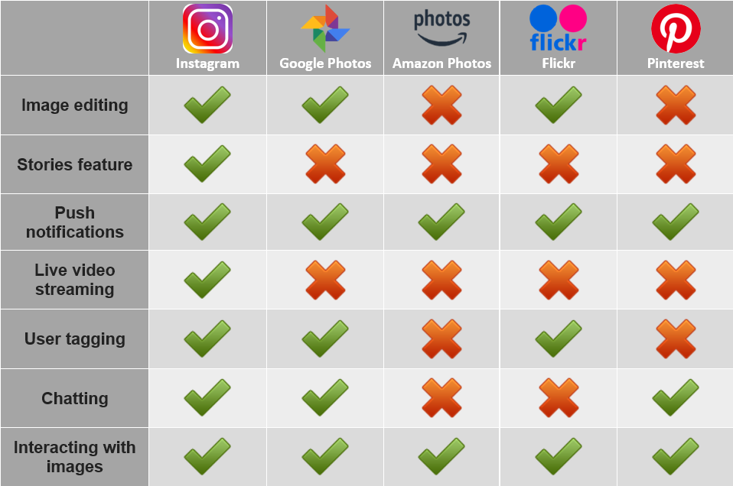

# Introduction

Pinterest is a website that allows users to upload or browse images sort them into collections. Each image is known as a “pin” and these are sorted onto “Boards”. To set up Pinterest as a personal user, you will need to sign up for an account. After setting up an account, you will be asked about what areas interest you. This allows Pinterest to give you a selection of people to follow with similar areas of interest as well as populating your feed.

Pinterest works as a visual bookmarking site. You are given the option to pin images to your chosen Board. You can also upload your own images to your Boards.

# General Description

| Description | Function |
| --- | --- |
| Allow the user to create an account with his data. | Sign up |
| Allow the user to log in to his account. | Log in |
| Allow the user to search in the categories of the images in the system | Search |
| Allow the user to follow any other user and to have followers | Following & Followers |
| Allow the user to create a board  (Board is like a place to save the favorite images ) | Create Board |
| Allow the user to upload an image and pin it in his/her profile | create Pin |
| Allow the user to have notification to the newest images in specific type | Notification |
| Allow user to chat with others and accept or reject their chat | chat |
| Allow user to see a user manual to help him in the site | Help |
| Allow user to pin specific image to board(collection of photos) | Add pin To board |
| Allow the user to make Emoji | interact with pin images |
| Recommend to the user some other types he may like them | Recommendation |

# User Requirements

A user can Follow the board or pin.A user can react to Pin. A user can search by board or pin .A user can add pins of others to his/ her board.A user can import an image with quite a small size. An user can learn how to use an application by help (user Manual). A User can find a description about his\her (as profile). There’s a Notification for an user. Only registered users can chat. An User can use the system smoothly.An User can change his/her password. User data must be secured.

# Functional Requirements

**Registration:**

* **Description: it allow user to make an account**
* **Input:Username , Password & Email**
* **Source: user**
* **Pre-condition: The user must have an email and don’t find before**
* **Post-condition: the information of the user will be added to the system**
* **Output: The Login form and confirm message ok**

**Login:**

* **Description: it allow user to login to his account**
* **Input:Username & Password**
* **Source: user**
* **Pre-condition: The user must register first**
* **Post-condition: Access his account**
* **Output: The Home page**

**Search:**

* **Description: it allow searching for boards, pins ,email and username**
* **Input:words of search**
* **Source: user**
* **Pre-condition: words of search is found in pinterest**
* **Post-condition: it shows all data that related with words of search**
* **Output: result of search(all data)**

**Following & Followers (Display ):**

* **Description: can follow the wanted pins , boards or person and vice-versa.**
* **Input: user**name of user**.**
* **Source: user**
* **Pre-condition: none**
* **Post-condition:none**
* **Output: display all following and followers**

**Create Board:**

* **Description: make a board where you save your Pins. You can create new boards from your profile or as you save a Pin.**
* **Input:** name of board and wanted pages**.**
* **Source: user**
* **Pre-condition:** the board that was not found before and display pages that are related with the subject of name boards .
* **Post-condition:** pages name add to your boards.
* **Output:** display configure that succeeded in creating a board.

**Create pin:**

* **Description: make an image to add or share as a pin to others .**
* **Input:** name of pin ,information pages and type of subject**.**
* **Source: user**
* **Pre-condition:** enter name of pin , information**.**
* **Post-condition:** add to pins to share on pinterest.
* **Output:** display configure that succeeded in creating a pin.

**Notification:**

* **Description:** display all notifications that are sent from the following pins or people **.**
* **Input:**username the user**.**
* **Source: user**
* **Pre-condition:** notifications that are sent to the entered user **.**
* **Post-condition:** display all data.
* **Output:** display notifications that sended.

**Chat:**

* **Description:** it allows you to make a message with your friend that is accepted **.**
* **Input:**friend that wants to chat with her/his**.**
* **Source: user**
* **Pre-condition:** friend that wants to send a message is found and accepts your request **.**
* **Post-condition:** save new message .
* **Output:** display all messages that storged.

**Help :**

* **Description:** helping to understand pinterest and interact with it **.**
* **Input:** none**.**
* **Source: user**
* **Pre-condition: none .**
* **Post-condition:** get that data.
* **Output:** display information about the system..

**Add pins:**

* **Description:** add pins and to boards that are related with subject and pins**.**
* **Input:** name of pin.
* **Source: user**
* **Pre-condition:** if pins are related with boards found in the system to add it on board **.**
* **Post-condition:** add pin to pins and board that is related .
* **Output: message saved**.

**Interact with pin (Like):**

* **Description:** like a pin if you want.
* **Input:** name of pin and interact.
* **Source: user**
* **Pre-condition: none** **.**
* **Post-condition:** save interact .
* **Output: display interact.**

**Recommendation:**

* **Description:** show pins that are related with subjects that he/she is interested with it**.**
* **Input:** none.
* **Source: system**
* **Pre-condition:** type of subject **.**
* **Post-condition:** get some pins that are related with a specific object .
* **Output:** .display of the pins.

# Non-Functional Requirements

**1.1** Import image: - upload image with maximum size 10 Mb.

**1.2** Search Time: Search with Maximum time of 2.5 seconds.

**1.3**  Navigation between pages :- Transfer between page with 3s time and speed.

**1.4** Security: - Third time a user enters the wrong password system stops the ability to log in for 3 minutes .

**1.5** username :- username must be unique.

**1.6** Ease of use: - It will take 50 minutes to get comfortable use .

**1.7** Appearance : - it shows instructions for using the app For the first Time a user starts the app.

**1.8** Password: - must be more than 8 contains at least one number ,

**1.9**  system representations:- it allows you to send messages with a person if only she/ he is a friend.

**1.10**  Capacity Of System:- A System should be capable enough to handle 100 users with affecting its performance.

**1.11** Availability**:-** System is required to be available for 80% of time**.**

# Appendices

**Pin** : image

**Board** : Collection of images

# Stakeholders

* Designer
* End-User
* Health and Safety
* Marketing
* Media
* photographer